Instructions for creating, merging, and pushing a branch on Eclipse, version Kepler

1. You can create a branch from the master branch by right clicking on it in the Git Repository and choosing create branch. Remember to choose the master branch in the “Remote Tracking” folder. It will add it then to the local folder for editing.

\*keep in mind anything done is not sent to the git server until it is pushed. So the branch and editing done in the local folder is just saved on the machine used until pushed.

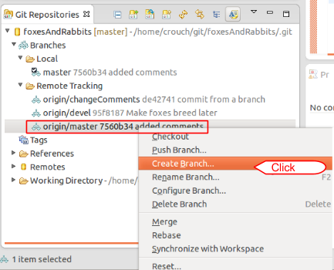

2. You assign the branch a name and then you can work from that branch.

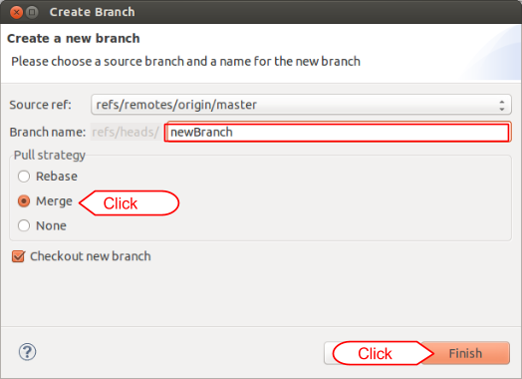

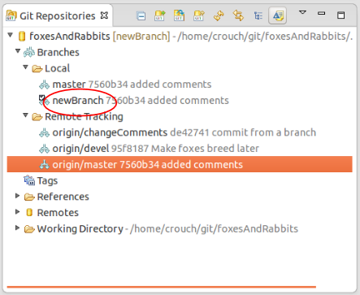

3. You can also switch between branches by selecting the branch you wish to edit on the Git Repository window. The branch with a check next to it is the one being used.

4. To commit, do the same as explained in the other steps for the branch you are on.

5. To merge the branch you created to the master, select the master and have it open.

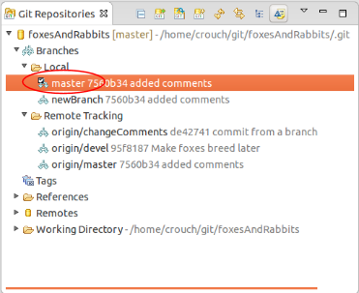

6. Right click on the branch you wish to merge and select merge. If Result is “Fast-forward” the merge can be done with no work. This is because there are no other changes present in the file we are trying to merge from. Click “Ok” and it will be put as the new master.

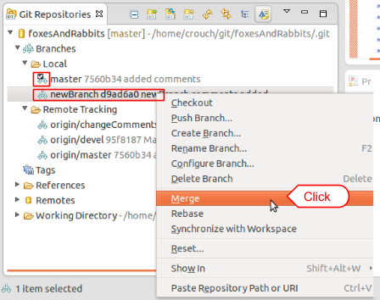

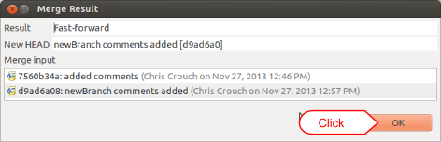

7. This will all have to be pushed to the upstream to be saved to github. With merged master branch selected, push it by right clicking on the project name, go to Team -> Push to Upstream

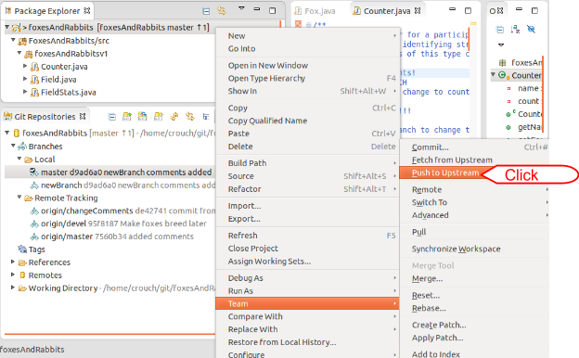

\*If you go to push to upstream and an error occurs because you do not have the most up to date version of the master

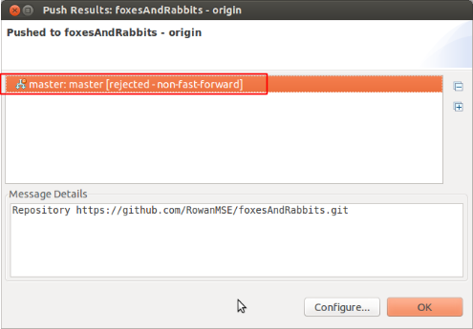

1. Right click on the project and go to Team -> Fetch from Upstream

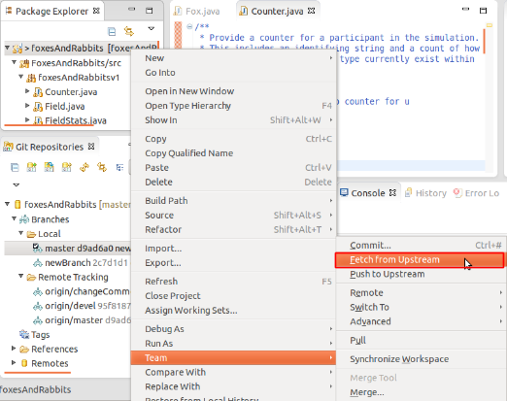

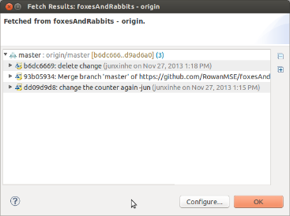

2. Having the master branch selected, right click on project and go to Team -> Pull. The result will be conflicting.

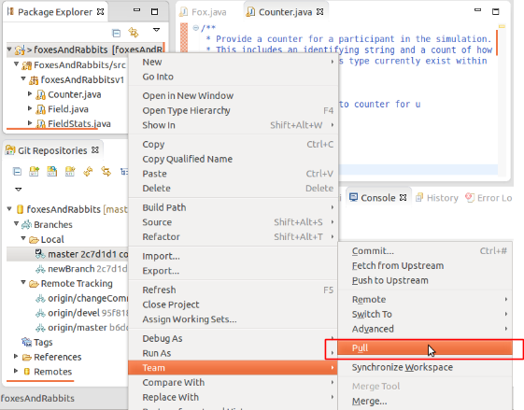

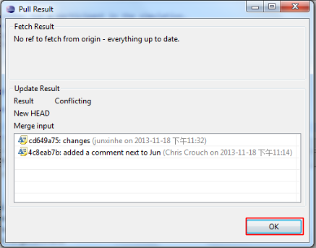

3. To resolve this visit the Git Staging window. Here click on the file under the Unstaged Changes section. Both files will appear with changes and merging that could be done. The rest has be done manually. Then, save the change.

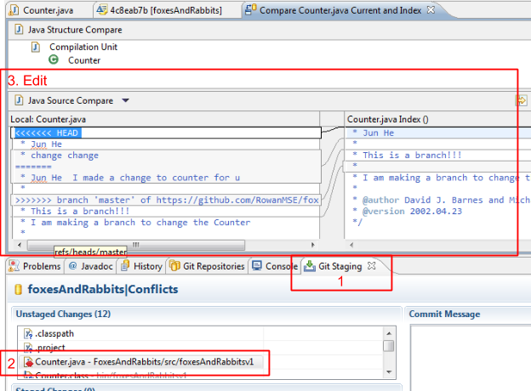

4. After that is complete move the file to the Staged Changes section and it is ready to be merged and commit.

